Applications of Genetic Algorithms in Data Mining
Faegan White – 20056628

Introduction

This paper will look at genetic algorithms (GAs) in the role of data mining, specifically with 3 aims. Firstly, a genetic algorithm for the role of data mining will be implemented and the affect of parameter tuning on testing and training accuracy explored. Secondly, the use of a GA in data mining will be compared with another meta-heuristic algorithm, the Social Spider Algorithm (SSA) to see how both techniques differ in approach and result. Finally, this paper will extend the capabilities of the data mining GA to learning the minimum number of rules required to categorise the data set, before using this optimised rule set to generate manual inferences about the data.

Background Research

Meta-heuristics is a field of artificial intelligence which uses higher-level procedures to construct heuristics for problem solving (Hussain et al., 2019). This can be split into single solution or population based algorithms – the latter providing an exploratory advantage through communication and interaction between solutions (Turgut and Turgut, 2020). Many population based meta-heuristics are considered NIOAs or Nature-inspired optimisation algorithms, which use natural phenomena for inspiration (Wang et al., 2021). A need of all meta-heuristics is to determine a balance between exploration and exploitation for effective search performance (Črepinšek et al., 2013). Focusing on exploration will find many novel solutions but struggle to converge, while too much exploitation risks sticking in a local optima (citation needed). Two examples of NIOAs are genetic algorithms, procedure based algorithms taking inspiration from biological evolution (Wang et Al., 2018) and Social Spider Optimisation (SSO), an equation based swarm intelligence using vectors, like Particle Swarm Optimisation (Yang, 2020) but taking inspiration from social spider colonies (Cuevas et al., 2013). Comparison of meta-heuristics is important to develop hybridised solutions and determining effective approaches for different problem domains (Wang et al., 2021). Because of this, a comparison between the two approaches is warranted.

One similarity between GAs and SSO is problem representation, both of which use a list to define the properties of the heuristic they represent. However in a GA, this sequence is labelled a gene (Lin et al., 2015) while in SSO, each spider represents a position in an N-dimensional web, where N defines the dimensions of the problem space (Cuevas and Cienfuegos, 2014). A key problem in multi-solution algorithms is the communication between solutions (Ma et al., 2019). For this, GAs use the processes of crossover to merge information, generating new genes from successful parents across the problem space (Wang, et al., 2018). In comparison, SSO uses the concept of vibrations to transmit information between spiders, where the strength of the vibration is dependant of the spider’s fitness and distance from the other solution in the web (Cuevas et al., 2013). Muti-population models also require a search method to find new solutions (Ma et al., 2019). Although crossover plays a large role in this, mutation is another mechanism GAs utilise which provides a searching force by randomly modifying a number of the solution’s genes (Alam, 2020). In SSOs however, spiders traverse the web stochastically according to their state and incoming vibrations to search the problem space (Cuevas et al., 2013). Building on this, SSO separates the population into ‘male’ and ‘female’ spiders, each sex with its own evolutionary rules and the ability to reproduce together to create a new populations. This individual categorisation reduces the risk of premature conversion and further tunes the balance between exploration and exploitation (Luque-Chang et al., 2018).

Ultimately, GAs are a general purpose search method with a balance between exploration and exploitation (Michalewicz, 1996). They are particularly effective for large scale, non-convex optimisation problems (James and Li, 2015) such as data mining. SSOs are only efficient for low-scale optimisation problems and have poor performance with continuous data sets with more than 10 dimensions (Baş and Ülker, 2020). Because of this, a closely related algorithm called the Social Spider Algorithm is more commonly used for data mining applications (Emine and Ülker, 2020) and will be investigated in this paper. The key differences are the use of consistent evolutionary rules between individuals, the introduction of ‘spider blasting’ and ‘spider memory’ to remove unfit solutions and store successful ones and an introduction of a dimension mask, a vector of length N which guides the spiders movement in each iteration (James and Li, 2015). This acts to improve local search and find new solutions on a larger scale (Baş and Ülker, 2020).

Experimentation
Data Mining Algorithm

Data mining is the process of finding patterns and correlations within data sets to predict outcomes (citation needed). Here, the data set is a list of items, each with a set of properties (represented as values between 0 and 1) and a binary class which it belongs to. The GA developed with Python for mining (the code for this can be found at Appendix A) has a genome where value pairs represent boundaries, and each rule constitutes as many pairs as the values of the data set, plus an extra value to represent the binary outcome. Thus, the rule size is

2n+1

where n is the number of data properties. The genome length is always a multiple of the rule size. An example rule from the genome may look like this:

0.2569752244532422
0.7677804675200207
0
1
0
1
0
0.6888602357571432
0
0.15995737319298753
0.26000303037706174
0.9649481569648961
0.07749397011045515
0
1
0.44498009030002783
0.7364319508474593

The key operations of the GA consist of single point crossover and mutation, controlled with parameters which balanced exploration, exploitation and algorithmic complexity. These parameters are…
- max_val – maximum genome value
- min_val – minimum genome value
- population_size – number of concurrent solutions
- generations – number of iterations
- rule_number – number of rules which compose the genome
- tournament_number – number individuals used in tournament selection
- mutation_chance – chance of any value in the genome mutating in each generation
- mutation_amount – maximum amount the value in the genome can mutate by
- repeat_times – number of times to repeat the entire algorithm for an averaged result

The fitness function represents the number of items for which the heuristic could successfully classify. This was calculated by comparing item values against each rule in turn, incrementing the fitness and moving to the next item if successfully matched.

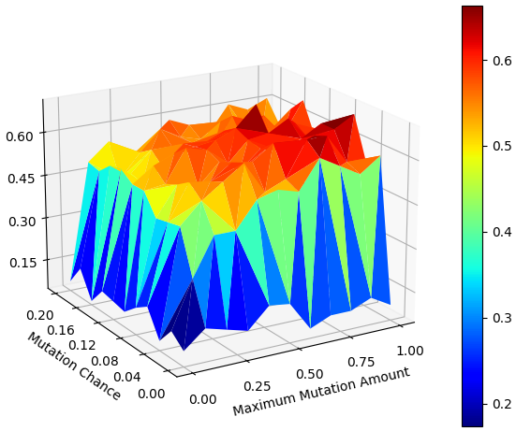
A sweep was performed for each data set, comparing mutation chance, maximum mutation amount and rule number, the results of which were later used to guide the operation of the algorithm. These results can be found at appendix A, B and C. From one sweep, a surface representing how mutation chance and mutation amount with an 11 rule genome on data set 1 affects the algorithm’s fitness was generated (Fig A). This suggested a mutation rate of 0.12 and a mutation amount of 0.8 were optimal, with fitness decreasing with a smaller maximum mutation amount or higher mutation chance.

With this sweep information, the algorithm was trained on the 3 data sets. The results of which can be seen in Fig. A, B and C.

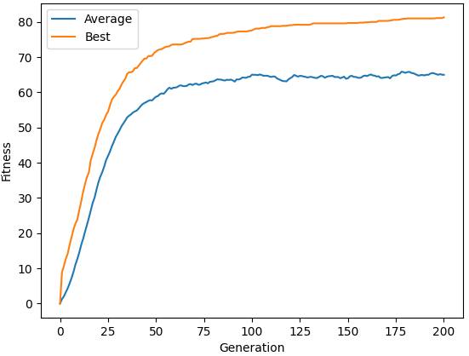
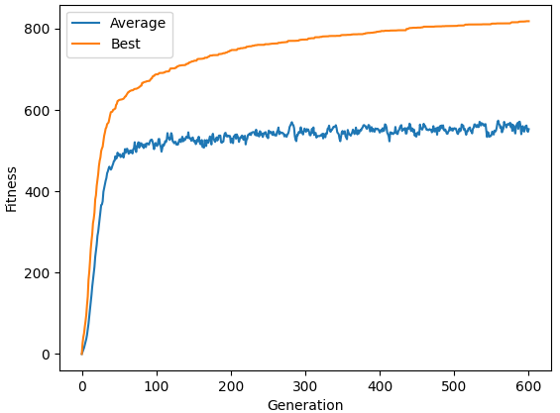

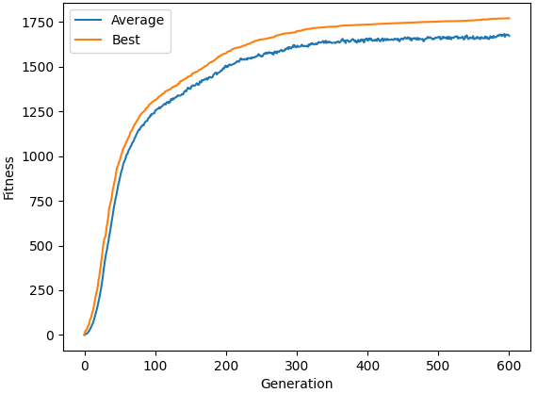
It was determined that increasing the population number found optimal solutions in fewer generations with more compute, by increasing genetic diversity for a wider search (citation needed). Increasing generation number produced a higher fitness but with the cost of more time. This was especially relevant with data set 2 and 3, which often required 500+ generations to achieve fitness over 80% during training. More rules meant more compute power and time as a larger genome needed to be processed, but too few was unable to fully capture the complexity of the data, leading to reduced maximum fitness. See Fig A, in which the GA genome had only two rules at its disposal.

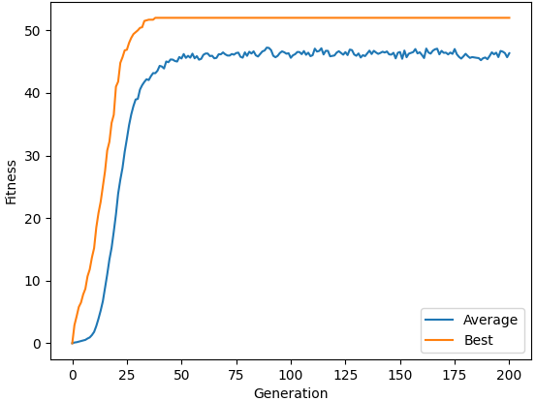

K-fold validation

To understand true classification accuracy, it’s vital to test the solution using unseen data (citation needed). K-fold validation was used, splitting the data into k sets, and then testing one set after training with the remaining k-1 sets, repeating the process k times before giving the average testing accuracy of all the sets as the solution’s fitness. This ensures that the algorithm is trained and tested on every data piece, giving a more robust and consistent measure of accuracy.

As expected, testing accuracy was lower compared to training (Table A). However, the larger the data set, the smaller the decrease in accuracy. This is because less data during training leads to an increased chance of overfitting (citation needed). This is magnified during k-fold validation, which further reduces the training data size. The average K-fold validation fitnesses for the 3 data sets can be seen compared in Fig A.

 | Data1 |  | Data2 |  | Data3
 | Training | Testing | Training | Testing | Training | Testing
1 | 0.82 | 0.57 | 0.8 | 0.76 | 0.87 | 0.84
2 | 0.82 | 0.58 | 0.8 | 0.78 | 0.87 | 0.84
3 | 0.81 | 0.6 | 0.78 | 0.73 | 0.89 | 0.85
4 | 0.84 | 0.62 | 0.81 | 0.77 | 0.86 | 0.85
5 | 0.82 | 0.58 | 0.82 | 0.8 | 0.89 | 0.85
6 | 0.81 | 0.54 | 0.82 | 0.8 | 0.87 | 0.85
7 | 0.83 | 0.72 | 0.82 | 0.78 | 0.89 | 0.86
8 | 0.83 | 0.61 | 0.8 | 0.77 | 0.87 | 0.84
9 | 0.8 | 0.55 | 0.82 | 0.78 | 0.87 | 0.83
10 | 0.82 | 0.53 | 0.82 | 0.8 | 0.87 | 0.86
Average | 0.82 | 0.59 | 0.81 | 0.78 | 0.88 | 0

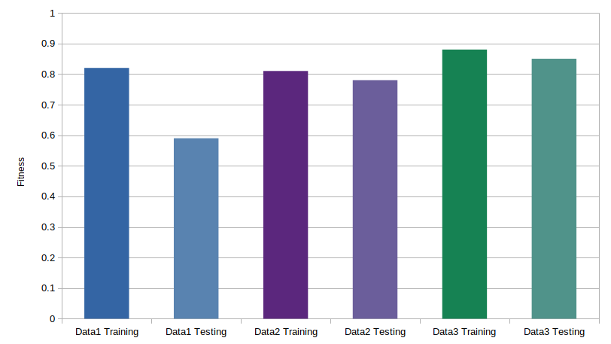

Comparison with Social Spider Algorithm

The SSA was created by obtaining source code from site X, and transferring into it the fitness function from the GA. The SSA represents the problem as an N dimensional web, where the position in each 2 dimensions make up 2 boundary values and 6 boundary value pairs construct a rule, with a 13th dimension being used to represent the output of the rule when rounded. Hence, a 35 dimensional web encodes 5 rules for classification, enabling each spider to become a heuristic for data mining.

The inputs to the algorithms were
- dimension – number of web dimensions, equivalent to the length of genome
- spider_number – number of solutions, equivalent to the population_size
- max_iteration – number of iterations, equivalent to generation_number
- r – probability of setting a value in the dimension mask to 1
- c – probability of changing the dimension mask during the walk step
- attenuation_rate – reduction of vibration intensity over distance

(James and Li, 2015)

Graphing the performance of individual spiders on data set 1 shows that the algorithm tended to get stuck at a local minimum representing the highest fitness possible with a single rule: 52 (Fig A). It also shows the large epoch number to achieve fitness comparable to the GA, suggesting the ability of the SSA to either explore the search space or exploit the current position isn’t as effective as the GA.

Fig A shows that the fitness increase in the SSA is slower, and it’s unable to reach the same level of accuracy of the GA. Both algorithms use 5 rules with a population of 100.
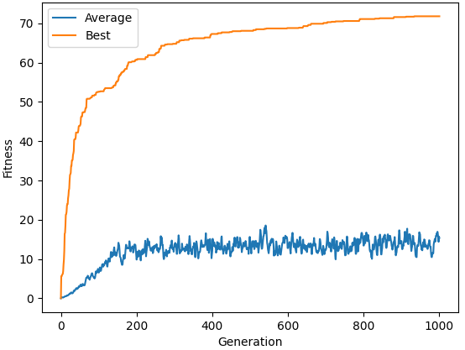

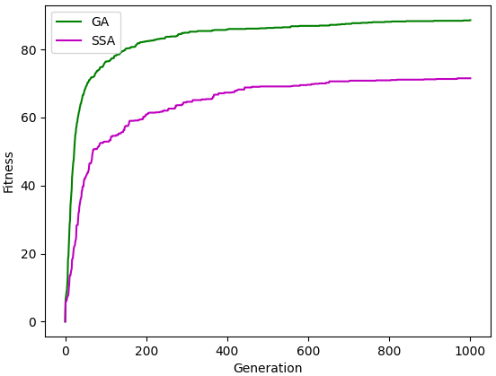
Variable Genome

Allowing the GA to evolve its own rule number while calculating solutions means compute power is used efficiently while solutions have the greatest balance of accuracy and complexity (citation needed). To implement this, single point crossover required adjustment to handle variable length genomes. This was done by picking a random point in the smaller genome’s length for the crossover point, and generating 2 solutions using alternating sections from either parent and randomly selecting one of the results.

To avoid inflating genome lengths, the gene size was introduced as a negative factor of tournament selection by prioritising fitness until within a defined range rule_size_factor, at which point the solution with the smallest gene would be selected. This allowed the control of the balance between gene size and fitness. The rule_mutation_chance parameter was also added to define the chance that a new random rule would be added onto the end of the individuals genome, or an old rule would be subtracted from the end. This ensured new rule numbers outside the parents were tested, increasing the search capability of the algorithm.

Fig A shows a demonstration of the variable genome GA, starting with 1 rule and learning to increase rule number to improve accuracy beyond 52 (the limit for a single rule).
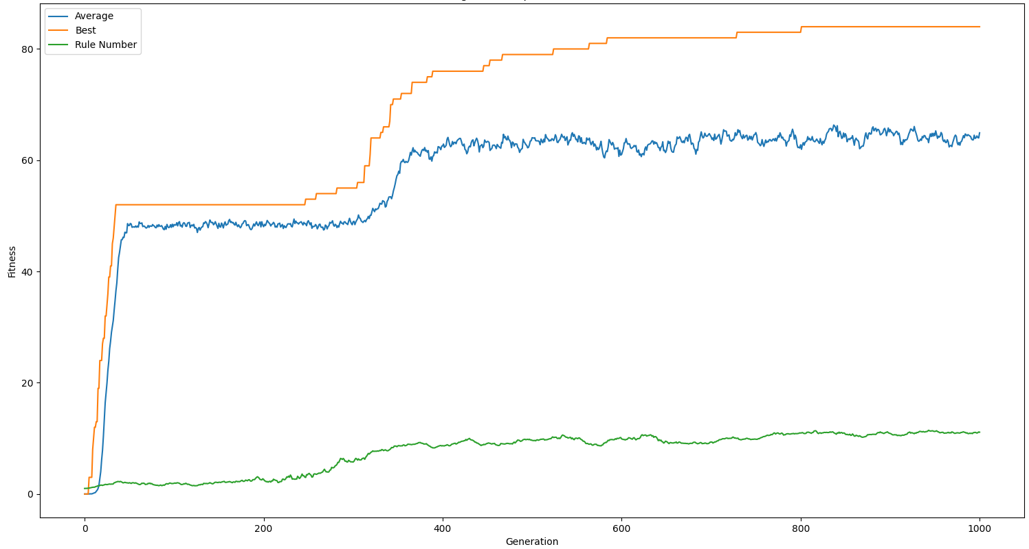
Table A and Fig A shows variable genome training on data set 1, where the average number of rules produced is 6.1 with an average fitness of 0.74. It’s clear that higher fitness can be achieved than the average, however it is prone to the local optima of 0.52 with a single rule.

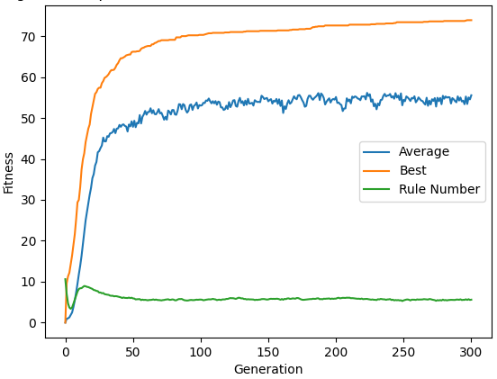
 | Training | Rule Number
1 | 0.78 | 12
2 | 0.89 | 5
3 | 0.52 | 1
4 | 0.82 | 10
5 | 0.68 | 9
6 | 0.52 | 1
7 | 0.83 | 7
8 | 0.72 | 7
9 | 0.76 | 3
10 | 0.87 | 6
Average | 0.74 | 6.1

To demonstrate that the variable genome was successfully converging on a consistent solution, it was important to test it with a variety of initial rule numbers. Fig A shows a maximum rule number of 40, where the algorithm converges to the same rule number as Fig A, demonstrating repeatability.
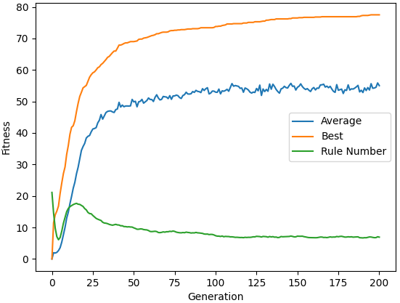
Nested K-Cross Validation Training

To improve these results, the concept of nested k-cross validation for hyperparameter selection of deep neural networks was explored. This splits every training epoch into a further number of folds, testing each fold using a different hyperparameter value before comparing accuracies and determining the highest, to be used as the hyperparameter for the next iteration (citation needed).

This was implemented in the GA by splitting each generation into cross_training_split_number of folds, each fold taking the previous generation’s population and modifying each individual to have a increasing proportion of the maximum rule number of rules. The fold with the highest accuracy, or equal accuracy but a smaller rule number is selected as the population for the next generation. If a generation was unable to produce an individual with higher accuracy or a smaller rule number, the algorithm will train the new generation with 2 more rules than the previous best generation to stop sticking to a low rule number from losses of genetic information.

To further retain genetic information and hence accuracy after the genome was shrunk, the concept of genome compression was introduced. This scores every individual's rule by the number of data pieces it classified when the fitness is calculated. When a genome is reduced in size, rules with 0 score were removed preferentially. This allows genomes to be compressed down smaller with a negligible affect on accuracy. Fig A shows this at work on data set 1, developing +80% accuracy with only 4 rules.
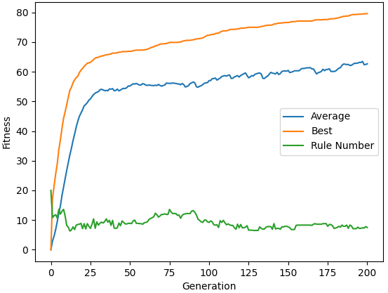
The rule compression system means solutions produced are reduced in complexity, improving readability and hence providing a better tool for manual analysis. However, nested k-cross validation (NKV) requires more compute power as every generation needs to calculate a set of folds. These results suggest that the variable genome GA is better for tasks where performance is more critical, but NKV may be more powerful when lower complexity, higher accuracy heuristics are preferred. Due to the presence of outlier results in the data set (NKV, items 1 and 4 according to a 90% confidence obtained via the confidence interval) Table A suggests NKV is both less consistent and has a higher average rule number…
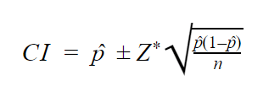

 | Variable Genome |  | Nested K-Cross Validation
 | Training | Rule Number | Training | Rule Number
0 | 0.78 | 12 | 0.84 | 4
1 | 0.89 | 5 | 0.76 | 21
2 | 0.52 | 1 | 0.82 | 4
3 | 0.82 | 10 | 0.75 | 7
4 | 0.68 | 9 | 0.75 | 21
5 | 0.52 | 1 | 0.84 | 4
6 | 0.83 | 7 | 0.86 | 4
7 | 0.72 | 7 | 0.82 | 4
8 | 0.76 | 3 | 0.73 | 2
9 | 0.87 | 6 | 0.79 | 4
Average | 0.74 | 6.1 | 0.8 | 7.5
Std. Dev. | 0.13 | 3.7 | 0.05 | 7.21

However, a simple filtering technique to re-compute results when the rule-numbers extend beyond pre-defined bounds would provide results similar to those shown in Table A, where NCV has the highest accuracy, lowest rule number and smallest standard deviations of the techniques when filtered.

 | Variable Genome |  | Nested Cross Validation
 | Training | Rule Number | Training | Rule Number
0 | 0.78 | 12 | 0.84 | 4
1 | 0.89 | 5 | 0.82 | 4
2 | 0.82 | 10 | 0.75 | 7
3 | 0.68 | 9 | 0.84 | 4
4 | 0.83 | 7 | 0.86 | 4
5 | 0.72 | 7 | 0.82 | 4
6 | 0.76 | 3 | 0.73 | 2
7 | 0.87 | 6 | 0.79 | 4
Average | 0.79 | 7.38 | 0.81 | 4.13
Std. Dev. | 0.07 | 2.88 | 0.05 | 1.36

As shown in Fig A, these results were consistent in data set 2. At a later date, the genome compression technique could be combined with the variable genome GA to produce a blend of these approaches, improving both performance and the rule compression ability of the algorithm.

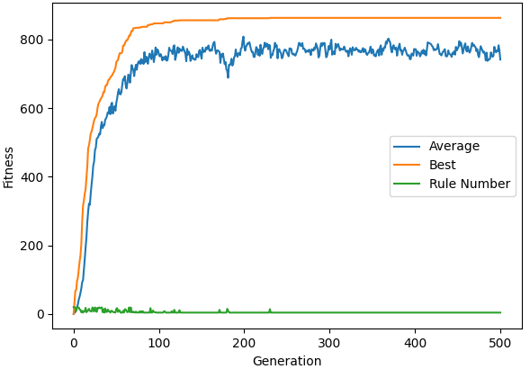

Deciphering the genome

As a final analysis, it’s important to investigate results produced by the algorithm in order to see what information about the data sets can be observed. This technique may be required in applications where data mining is used for feature extraction of the data set, which can be later be used for data manipulating (citation needed).

To examine the algorithm’s results, the highest performing genome from the NKV technique with genome compression from data set 1 is investigated as it had the highest fitness while retaining a small genome, making the results easier to interpret. Here is the genome outputted from the algorithm:

[0.2569752244532422, 0.7677804675200207, 0, 1, 0, 1, 0, 0.6888602357571432, 0, 0.15995737319298753, 0.26000303037706174, 0.9649481569648961, 0.07749397011045515, 0, 1, 0.44498009030002783, 0.7364319508474593, 0, 1, 0.5200849129225364, 1, 0, 0.25707352320440807, 0, 0.9557817431268466, 0.32577905218928643, 0, 1, 0.15480047310444878, 0.9357823727920461, 0, 1, 0, 0.8869180910372175, 0, 1, 0.004498101765539553, 1, 0.5669909776062353, 0, 0.9356717669425502, 0, 1, 0, 1, 0, 1, 0.03160604062202066, 0.4200950638805167, 0.6591731387680398, 1, 0.6906413877321006]

The values are rounded to 2 decimal places while the classification is rounded to the nearest whole number for easier analysis:

[0.25, 0.76, 0, 1, 0, 1, 0, 0.68, 0, 0.15, 0.26, 0.96, 0,
0, 1, 0.44, 0.73, 0, 1, 0.52, 1, 0, 0.25, 0, 0.95, 0,
0, 1, 0.15, 0.93, 0, 1, 0, 0.88, 0, 1, 0.00, 1, 1,
0, 0.93, 0, 1, 0, 1, 0, 1, 0.031, 0.42, 0.65, 1, 1]

Separated out by pair and then highlighted to reflect the gap size between value pairs:

0.25, 0.76, 0, 1, 0, 1, 0, 0.68, 0, 0.15, 0.26, 0.96, 0
0, 1, 0.44, 0.73, 0, 1, 0.52, 1, 0, 0.25, 0, 0.95, 0
0, 1, 0.15, 0.93, 0, 1, 0, 0.88, 0, 1, 0.00, 1, 1
0, 0.93, 0, 1, 0, 1, 0, 1, 0.031, 0.42, 0.65, 1, 1

The first insight from these rules is that both 5th position pairs were very strict around the value of 0 for the first classification, suggesting that to be classified in the first group, the 5th value in the data should be 0 or close to it. Another inference is that for both data types, the 3rd value pair accepts any value. This means the 3rd value in any piece of data is independent of it’s classification. Finally, the 6th value pair for the first class doesn’t extend to 1, suggesting that the 6th value shouldn’t be higher than 0.96.

This analysis demonstrates that the results obtained from the genetic algorithm can be manually analysed, and suggests that changes to the way in which the data is recorded could be implemented in the future to reduce complexity. For example, it could be argued that the collection of the 3rd value for each data piece is likely unnecessary, as it doesn’t play a role in classification.

Conclusions

Next time it would be worth exploring how different crossover and selection algorithms affected performance. Could then use nested cross validation to decide on the best method for the given problem

